## Exercise 1.2.6: Your First HTML Page

In this exercise you’ll make your first fully formed HTML document from scratch!

Create a webpage with the title “My First Web Page”

The content of the page should have an <h1> tag that states your favorite band.

If you open your page in a new window using the “See HTML in new window” button, you should see your page title in the browser tab.

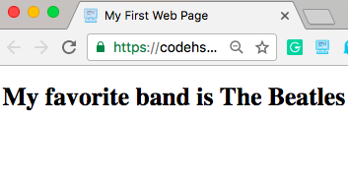

HINT: Use the previous HTML Template example as a starting point. You’ll need to use the <html> <head> <body> and <title> tags, and be sure to set the DOCTYPE as well.